LAB 10 TASKS
COAL
24K-0559
BAZIL-UDDIN-KHAN

BSCS-3H

TASK#1).
CODE:
INCLUDE Irvine32.inc

.data
HeightInput DWORD ?
WidthInput DWORD ?
Msg1 BYTE " Enter Height Of Pixel : ",0
Msg2 BYTE " Enter Width Of Pixel : ",0
Msg3 BYTE " The Result Of Pixel is : ",0

.code
main PROC

mov ecx, 3
loopV:
mov edx, OFFSET Msg1
call WriteString
call ReadInt
mov HeightInput, eax

mov edx, OFFSET Msg2
call WriteString
call ReadInt
mov WidthInput, eax

push WidthInput
push HeightInput
call CalcSpriteArea

mov edx, OFFSET Msg3
call WriteString
call WriteDec
call Crlf

loop loopV

exit
main ENDP

CalcSpriteArea PROC
push ebp
mov ebp, esp
push ebx

mov eax, [ebp+12]
mov edx, 0
mov ebx, [ebp+8]

cmp eax, 0
jle WrongInput
cmp ebx, 0
jle WrongInput

mul ebx
jmp Lexit

WrongInput:
mov eax, 0

Lexit:
pop ebx
pop ebp
ret 8
CalcSpriteArea ENDP

END main

OUTPUT:
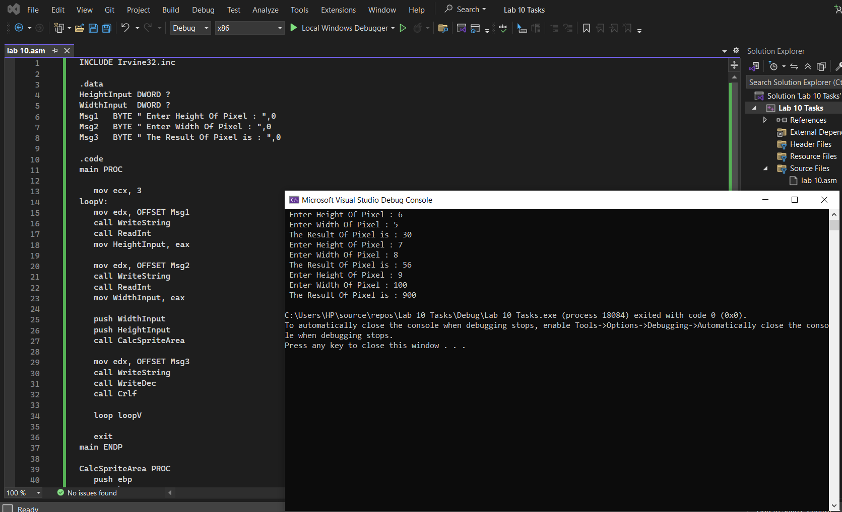

TASK#2).
CODE:
Include Irvine32.inc

.data
communicationport Dword ?
failoverbackupport Dword ?
Msg1 Byte " Enter Communication Port ",0
Msg2 Byte " Enter Fail Over Port ",0
Msg3 Byte " Updated Communication Port ",0
Msg4 Byte " Updated Fail Over Port ",0

.code
main Proc

mov edx,OFFSET Msg1
call WriteString
call ReadInt
mov communicationport,eax

mov edx,OFFSET Msg2
call WriteString
call ReadInt
mov failoverbackupport,eax

push OFFSET communicationport
push OFFSET failoverbackupport
call SwapPorts

mov edx,OFFSET Msg3
call WriteString
mov eax,communicationport
call WriteInt

mov edx,OFFSET Msg4
call WriteString
mov eax,failoverbackupport
call WriteInt

exit
main ENDP

SwapPorts Proc
push ebp
mov ebp,esp
push ebx
mov eax,[ebp+8]
mov ebx,[ebp+12]
mov ecx,[eax]
mov edx,[ebx]

mov [eax],edx
mov [ebx],ecx

pop ebx
pop ebp
ret 8

SwapPorts Endp

End Main

OUTPUT:
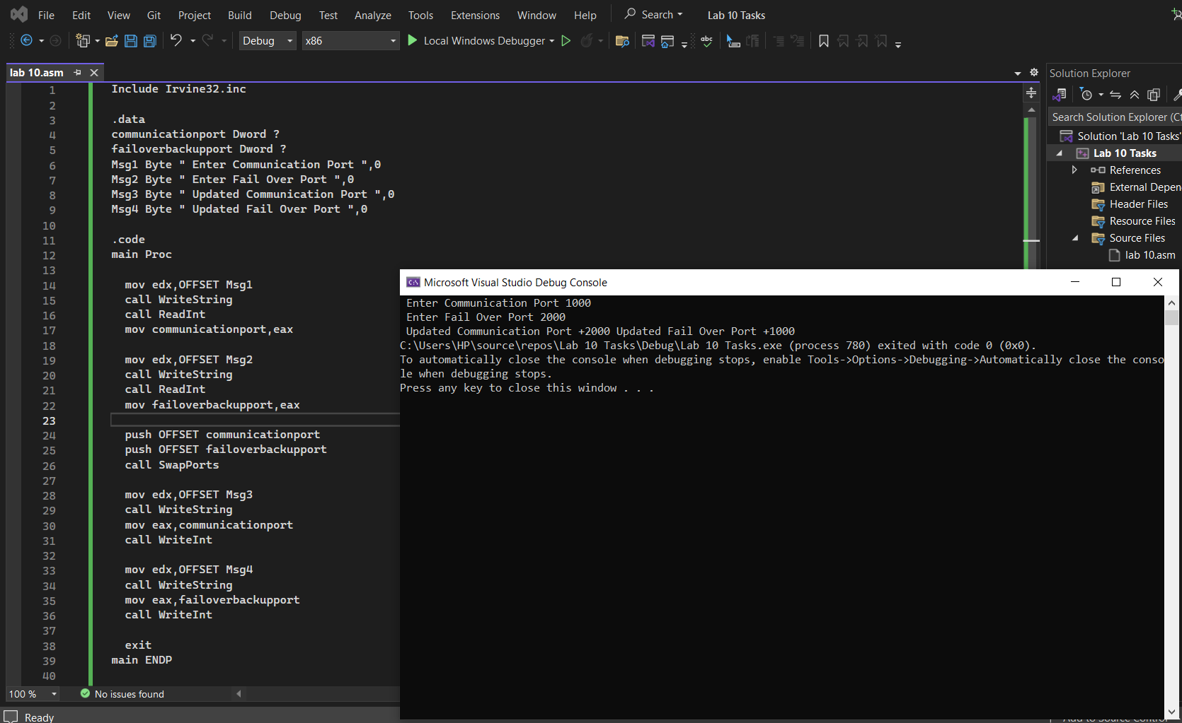

TASK#3).
CODE:
Include Irvine32.inc

.data
Transactions Dword 150,200,75,400
Msg Byte " Sum Of Transactions Is : ",0

.code
SumTransactionList PROTO Transaction : DWORD ,Count : DWORD
main Proc

Invoke SumTransactionList,ADDR Transactions,LENGTHOF Transactions
mov edx,OFFSET Msg
call WriteString
call WriteInt

exit

main ENDP

SumTransactionList Proc Transaction:DWORD ,Count: DWORD

Local Sum : Dword
mov esi,Transaction
mov Sum,0
mov ecx,Count

LoopSum:
mov eax,[esi]
add sum,eax

add esi,4
loop LoopSum

mov eax,sum
ret

SumTransactionList Endp
End Main

OUTPUT:
